*Software Testing Assignment*

Module – 3 (Testing on Live Application)

1. What is RDBMS

Relational Model (RM) represents the database as a collection of relations. A relation is nothing but a table of values. Every row in the table represents a collection of related data values. These rows in the table denote a real-world entity or relationship.

The table name and column names are helpful to interpret the meaning of values in each row. The data are represented as a set of relations. In the relational model, data are stored as tables. However, the physical storage of the data is independent of the way the data are logically organized.

1. What is SQL

SQL stands for Structured Query language, pronounced as “S-Q-L” or sometimes as “See-Quel” … Relational databases like MySQL Database, Oracle, MS SQL Server, Sybase, etc. use ANSI SQL.

SQL is a database language designed for the retrieval and management of data in a relational database.

SQL is the standard language for dealing with Relational Databases. SQL can be used to insert, search, update, and delete database records. SQL can do lots of other operations, including optimizing and maintenance of databases.

All the RDBMS systems like MySQL, MS Access, Oracle, Sybase, Postgres, and SQL Server use SQL as their standard database language. SQL programming language uses various commands for different operations

1. Write SQL Commands

Here are five types of widely used SQL queries.

• Data Definition Language (DDL)

• Data Manipulation Language (DML)

• Data Control Language (DCL)

• Transaction Control Language (TCL)

• Data Query Language (DQL)

[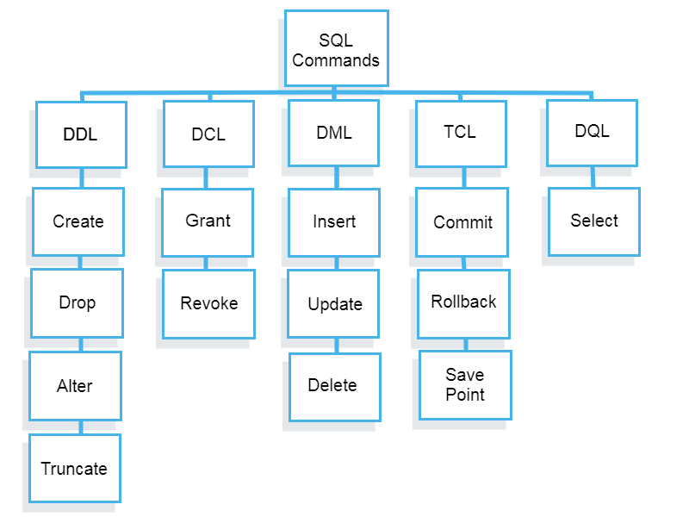](https://www.guru99.com/images/2/sql_commands1.png)

1. What is join?

Joins help retrieving data from two or more database tables.

The tables are mutually related using primary and foreign keys.

Note: JOIN is the most misunderstood topic amongst SQL leaners. For sake of simplicity and ease of understanding, we will be using a new Database to practice sample.

1. Write type of joins.

• Cross JOIN

Cross JOIN is a simplest form of JOINs which matches each row from one database table to all rows of another.

In other words, it gives us combinations of each row of first table with all records in second table.

Suppose we want to get all member records against all the movie records, we can use the script shown below to get our desired results.

[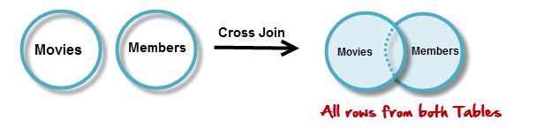](https://www.guru99.com/images/CrossJoin.png)

### **INNER JOIN**

The inner JOIN is used to return rows from both tables that satisfy the given condition.

Suppose, you want to get list of members who have rented movies together with titles of movies rented by them. You can simply use an INNER JOIN for that, which returns rows from both tables that satisfy with given conditions.

[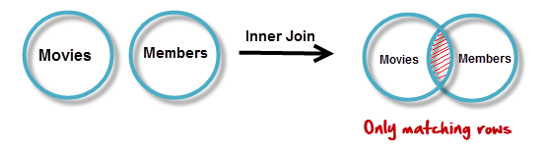](https://www.guru99.com/images/InnerJoin.png)

• Outer JOINs

MySQL Outer JOINs return all records matching from both tables.

It can detect records having no match in joined table. It returns NULL values for records of joined table if no match is found.

Sounds Confusing? Let’s look into an example –

• LEFT JOIN

Assume now you want to get titles of all movies together with names of members who have rented them. It is clear that some movies have not being rented by anyone. We can simply use LEFT JOIN for the purpose.

[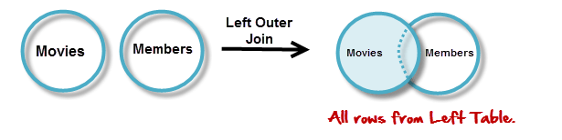](https://www.guru99.com/images/LeftOuterJoin.png)

The LEFT JOIN returns all the rows from the table on the left even if no matching rows have been found in the table on the right. Where no matches have been found in the table on the right, NULL is returned.

• RIGHT JOIN

RIGHT JOIN is obviously the opposite of LEFT JOIN. The RIGHT JOIN returns all the columns from the table on the right even if no matching rows have been found in the table on the left. Where no matches have been found in the table on the left, NULL is returned.

In our example, let’s assume that you need to get names of members and movies rented by them. Now we have a new member who has not rented any movie yet

[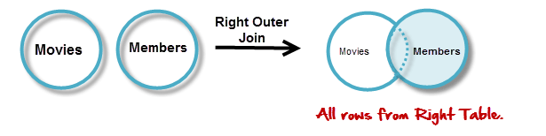](https://www.guru99.com/images/RightOuterJoin.png)

• “ON” and “USING” clauses

In above JOIN query examples, we have used ON clause to match the records between table.

USING clause can also be used for the same purpose. The difference with USING is it needs to have identical names for matched columns in both tables.

In “movies” table so far, we used its primary key with the name “id”. We referred to same in “members” table with the name “movie_id”.

Let’s rename “movies” tables “id” field to have the name “movie_id”. We do this in order to have identical matched field names.

1. How Many constraints and describes it self

It would depend on various factors such as the complexity of the application, the type of testing being conducted (e.g., functional testing, performance testing, security testing), and the specific requirements of the application.

Constraints in testing typically refer to limitations or conditions that must be adhered to during the testing process. These constraints can include factors such as time, budget, resources, and technical limitations.

In terms of self-descriptive nature, some testing frameworks or methodologies may incorporate descriptive elements within their constraints to provide clarity and guidance to testers. For example, in Behavior-Driven Development (BDD), tests are often written in a self-descriptive format using natural language constructs to make them more understandable to stakeholders.

1. Difference between RDBMS vs DBMS

RDBMS (Relational Database Management System) and DBMS (Database Management System) are both systems for managing databases, but they have some key differences, particularly when it comes to testing on live application.

- RDBMS: Organizes data into structured tables with rows and columns. Data is stored in a structured format and follows a relational model, with relationships defined between tables.

- DBMS: Can organize data in various ways, including hierarchical, network, or object-oriented models. It doesn't necessarily enforce the relational model as strictly as RDBMS.

- RDBMS: Enforces integrity constraints, such as primary key, foreign key, unique key, and check constraints to maintain data integrity.

- DBMS: May or may not enforce integrity constraints, depending on the specific implementation. It provides basic data management functionalities without strict enforcement of relational integrity.

- RDBMS: Generally, more complex than DBMS due to its adherence to relational principles and support for complex queries and transactions.

- DBMS: Can be simpler in terms of data organization and operations compared to RDBMS.

- Testing on an RDBMS requires thorough validation of relational integrity constraints to ensure data consistency across tables.

- DBMS may not have as strict constraints, so testing for data consistency might involve different approaches depending on how the data is organized and managed.

- RDBMS typically offers optimized query execution strategies for complex SQL queries involving joins, subqueries, and aggregations.

- DBMS may have limitations in query optimization, so testing should include performance testing to ensure that database operations perform adequately under various loads.

- RDBMS provides transaction management features to ensure ACID (Atomicity, Consistency, Isolation, Durability) properties.

- DBMS may have limited support for transactions or may not provide guarantees for ACID properties, which can impact the testing approach for transactional applications.

- RDBMS often includes tools and utilities for data migration, backup, and recovery.

- DBMS may have fewer built-in tools for data migration and backup, requiring additional testing and validation of these processes.

1. What is API Testing

API Testing is a software testing type that validates Application Programming Interfaces (APIs). The purpose of API Testing is to check the functionality, reliability, performance, and security of the programming interfaces.

In API Testing, instead of using standard user inputs(keyboard) and outputs, you use software to send calls to the API, get output, and note down the system’s response. API tests are very different from GUI Tests and won’t concentrate on the look and feel of an application. It mainly concentrates on the business logic layer of the software architecture.

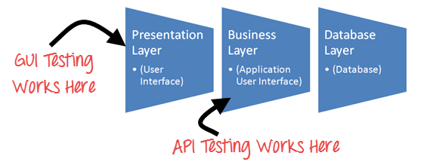

For background, API (Application Programming Interface) is a computing interface that enables communication and data exchange between two separate software systems. A software system that executes an API includes several functions/subroutines that another software system can perform. API defines requests that can be made, how to make requests, data formats that can be used, etc., between two software systems.

1. Types of API Testing

There are mainly four main types of APIs:

• Open APIs: These types of APIs are publicly available to use like OAuth APIs from Google. It has also not given any restriction to use them. So, they are also known as Public APIs.

• Partner APIs: Specific rights or licenses to access this type of API because they are not available to the public.

• Internal APIs: Internal or private. These APIs are developed by companies to use in their internal systems. It helps you to enhance the productivity of your teams.

• Composite APIs: This type of API combines different data and service APIs.

1. What is Responsive Testing?

The term responsive testing is a range of activities that involve it to check whether the website or any application is behaving in the right way after it is launched on different gadgets and screen sizes. The tests used to check whether the user interface changes dynamically in response to different screen resolutions, device orientations, and capabilities act as one of the major aims of testing.

As we are dealing with the spread of mobile devices as well as different variations regarding screen sizes and resolutions, it is now almost impossible to content the users with the same perfect screen experience – let alone the additional type of devices with nature-based handcrafted user interfaces.

1. Which types of tools are available for Responsive Testing

There are many different types of responsiveness testing tools available to test a website or web application:

• Device farms and emulators: Device farms and emulators can be useful tools for responsive testing because they allow you to test your site on a variety of different devices and screen sizes without physically accessing the devices. Online device farms such as Lambda Test provide you with access to real devices and emulators that emulate the experience of using actual mobile phones on your site. This can be particularly useful for testing devices you need access to or are unavailable in your location.

• Browser extensions: Several browser extensions, such as Window Resizer for Chrome and Responsive Design Mode for Firefox, allow you to test your site on different screen sizes within your browser. These extensions can be particularly useful for quickly testing small changes or for testing on a large number of screen sizes without having to access multiple devices physically.

• Responsive design frameworks: Responsive design frameworks provide a set of standardized styles and layout elements to help you create a responsive website. These frameworks often include tools for testing and debugging responsive layouts.

• Debugging tools: There are also several debugging tools available such as the dev-friendly LT Browser 2.0, that can help you identify and fix issues with your site's responsive design across a plethora of device viewports.

It is essential to use various tools and techniques to ensure that your site is thoroughly tested and functions properly on all devices.

1. What is the full form of .ipa, .apk

• Full Form of APK (What Is APK)

APK file stands for (Android Application Package). APK is a file extension of an Android device. APK files can normally be used in Android and a number of other Android-based Operating Systems for the distribution and installation of mobile apps and mobile games.

• Full Form of IPA (What Is IPA)

An IPA (iOS App Store Package) file is an iOS application archive file that stores an iOS app. Each IPA file includes a binary and can only be installed on an iOS device.

1. How to create step for to open the developer option mode ON?

Go to Settings: Open the Settings app on your Android device. You can usually find it in the app drawer or by swiping down from the top of the screen and tapping the gear icon.

Scroll Down: Scroll down the settings menu until you find an option called "About phone" or "About device." This option may be located under different headings depending on your device, but it typically contains information about your device, such as model number and software version.

Tap on "About Phone": Once you find "About phone" or a similar option, tap on it to open.

Find "Build Number" or "Software Information": In the "About phone" section, look for an option called "Build number" or "Software Information." This option might be located at the bottom of the list.

Tap "Build Number" Repeatedly: Tap on "Build number" repeatedly (usually about 7 times). You'll see a message saying something like "You are now X steps away from being a developer" with a countdown.

Enter Your PIN or Password: If prompted, enter your device's PIN, password, or pattern to confirm your action.

Developer Options Enabled: After tapping on "Build number" enough times, you'll see a message saying "You are now a developer!" or similar. This means that Developer Options has been enabled on your device.

Access Developer Options: Now, go back to the main settings menu. You'll see a new option called "Developer options" or "System" with Developer Options underneath it. Tap on it to access the Developer Options menu.